The Trial and Execution of King Charles I

Source A: Extracts from the proceedings of the Trial of King Charles I, 20 January 1649

The King was placed in a Chair, with his face towards the Court. Silence was ordered and Lord President [John] Bradshaw stood up and said:
“Charles Stuart, King of England, The Commons of England assembled in Parliament, being deeply sensible of the Calamities that have been brought upon this Nation (which is fixed upon you as the principal Author of it) have resolved to make inquisition for Blood, and... have resolved to bring you to Trial and Judgment, and for that purpose have constituted this High Court of Justice...”

[The Charge against Charles was read out] the prisoner sat down, looking very sternly, and was unmoved until the words “Tyrant and Traitor” were read, at which he laughed as he sat in the face of the Court....

Lord President John Bradshaw: “Sir you have now heard the Charge [against you] read... it is prayed by the Court, on behalf of the Commons of England, that you answer to your Charge. The Court Expects your Answer.”

The King: “I would know by what power I am called hither... I would know by what Authority, I mean lawful [authority]. There are many unlawful authorities in the world: thieves and robbers by the highways....
...Remember I am your King, your lawful King and what sins you bring upon your heads, and the Judgement of God upon this Land, think well upon it, I say, think well upon it, before you go further from one sin to a greater. Therefore let me know by what lawful Authority I am seated here, and I shall not be unwilling to answer; in the meantime I shall not betray my Trust; I have a Trust committed to me by God, by old and lawful descent. I will not betray it to answer a new unlawful Authority....”

Lord President Bradshaw: “[The Authority that brings you here] is in the name of the People of England, of which you are elected King....”

The King: “No Sir, I deny that... England was never an Elective Kingdom, but an Hereditary Kingdom for near these thousand years; therefore let me know by what Authority I am called here. I do stand more for the Liberty of my people than any here that come to be my pretended Judges....”

[Note by editor]: It is observed,
That as the Charge was read against the King, the head of the staff he was holding fell off, which he wondered at, and seeing no-one pick it up for him, he stooped for it himself.

As the King was taken away from the Court, he said “I do not fear that” (meaning the sword). The people in the Hall as he went down the stairs cried out, some “God save the King” and most for “Justice”.

Sources B: Extracts from Charles I’s speech at his execution 30 January 1649

“[I am] for the people... I desire their Liberty and Freedom as much as anybody whomsoever, but I must tell you, that their Liberty and their Freedom consists in having of Government [and] Laws... It is not for having a share in Government (sir) that is nothing pertaining to them; A Subject and a Sovereign are clean different things... Sirs, It was for this that now I am come here [to my death]: If I would have given way to an arbitrary way [i.e. the court that tried him]... to have all Laws changed according to the power of the Sword, I needed not to have come here [i.e. to his execution], and therefore I tell you... that I am the Martyr of the People... I go from a corruptible to an incorruptible Crown, where no disturbance can be, no disturbance in the world....”

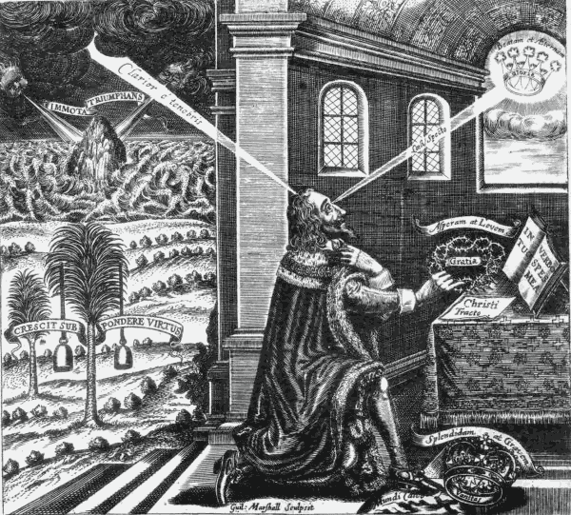
Source C: Image of King Charles I from Eikon Basilike (1649)

